55th Melbourne Gang Show (& Cub Sleepover!)



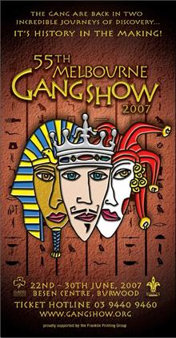
The Scouts and Guides of Victoria present the 55th Melbourne Gang Show, at the Besen Centre, Burwood.

See also: http://www.gangshow.org

Rosanna Cubs (& parents, siblings etc., welcome too!) will attend the 2pm performance on Saturday, 23rd of June.

Following the performance, we’ll be coming back to the Hall for a family BBQ, and then the parents and siblings will leave us and the Cubs will have a sleepover in the Hall.

Costs for the performance (bulk discount) are:
- Adults: $15
- Children: $10
- Family BBQ: $5 per person.

➔ We need to get our bookings in for the show as soon as possible, to enable us to get the best possible seats at the performance. Once we’ve put the booking in, you may still be able to buy tickets for the performance, but you’ll be seated elsewhere in the theatre and the ticket prices will be $5 higher due to missing the bulk discount.

Please return the tear off form below – By Tuesday 8th May!. We’ll then get our tickets organised.

Come along and have a ball!

55th Melbourne Gang Show, 2006
We’re coming along….
(1) Family Name:______________________ Cub(s):______________________

(2) TOTAL number of tickets required (including Cubs):
Adults ($15):______________________ = $____

Child ($10): ______________________ = $____

(3) Attending the BBQ? ………………………….. Number @ $5:____________________ = $____

Total: = $____
(4) Cub(s) staying for sleepover ? Free!: Y / N

Please bring this slip in on Tuesday 8th, so we can get our tickets organised!

